**ELECTRONIC STORE**

**DEPLOYMENT MANUAL**

Step 1: Download the all document of project from the given GitHub link

=> git clone <https://github.com/Bao-Thanh/GroupB-HCL-Project>

Step 2: Open any Oracle A database management tool and import (2)Database Backup(.Sql file).sql file

*Example: Oracle SQL Developer

Step 3: Open STS and import the electronic-store folder (with path ~\GroupB-HCL-Project\(0) Project_Source_Code\Backend\ ).

Step 4: Go to your application properties and change the credentials according to your system.

Step 5: The port number we have given is 8094, if this port is busy, change the port number.

Step 6: Run the project as spring boot application as shown in the picture below.

Step 8: Open VS Code and open the electronic-store-project-client folder (with path ~\ GroupB-HCL-Project\(0) Project_Source_Code\Frontend\ ).

Step 9: Open terminal and type “npm install”

*Note: if in step 5 you can change port other than 8094, please change port 8904 in API_URL string to that port in all service file

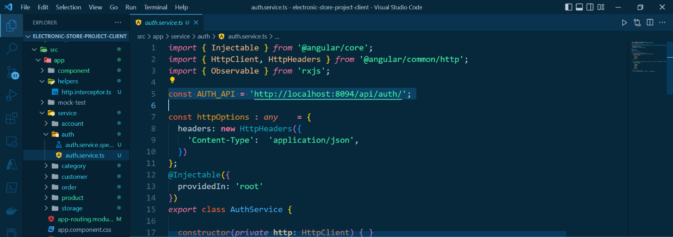

Step 10: Continue to type “npm start” in terminal

Step 11: If the program is successfully executed, the terminal will be as shown below

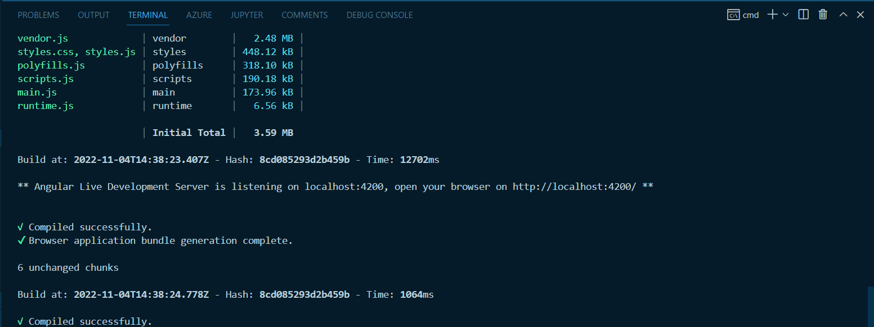

Step 12: Open up your web browser and type localhost:4200

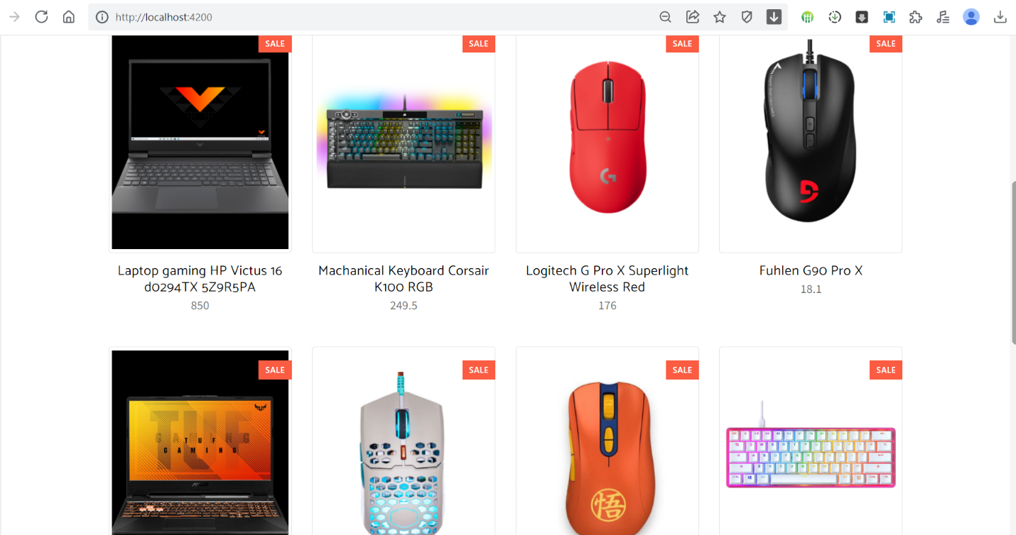

The main page

Step 13: To purchase products, you must log in to the system (all accounts in the database are provided in the table below)

- Admin

|  |  |  |
| --- | --- | --- |
| **#** | **Username** | **Password** |
| 1 | admin | admin123 |

- User

|  |  |  |
| --- | --- | --- |
| **#** | **Username** | **Password** |
| 1 | son123 | son123 |
| 2 | manh123 | manh123 |
| 3 | hoang123 | hoang123 |
| 4 | van123 | van123 |
| 5 | thanh123 | thanh123 |

Login with username: thanh123 and password: thanh123

Login successfully in to the system

* Note: if you don't have an account, you can sign up by clicking "Create a free account" in the login page or clicking SignUp Page on the navigation bar

=> If you click Signup button with all valid value, the system will automatically redirect to login page

Step 14: Click "shop" in the navigation bar to see all products

*View product by category

Step 15: Click any product to see product detail

Step 16: To buy product click "Add to cart"

Step 17: After completing the purchase, click "View cart" to go to cart page

Step 18: Fill your phone number and address, and click "Order" to order

After successful order

Step 19: Click "Orders" on the navigation bar to review all order information

Step 20: Click "View" button to view order detail

**With Admin role**

Click "Dashboard" on navigation bar to manage all product (CRUD)

- Read, Update and Delete product

- Create new product

